**Remote Learning Resources**

Student, Staff, and Family Logins: [Portal Log-ins - Guilford County Schools](https://www.gcsnc.com/login/portals)

Z-Scaler Login

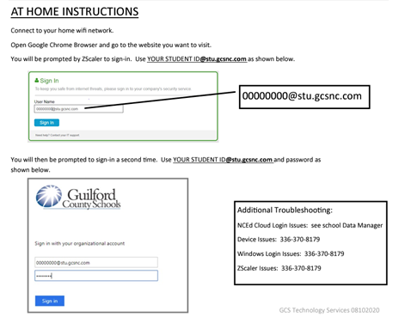

**Google Drive:** [drive.google.com/a/mygcsnc.com](https://drive.google.com/a/mygcsnc.com) **Username:** Last name + first initial + last four of Student ID @mygcsnc.com (example: [parkerp1234@mygcsnc.com](mailto:parkerp1234@mygcsnc.com)) **Password:** Student birthday (mmddyyyy) *If the student’s last name is hyphenated or made up of two names with a space between, type both names without a hyphen or a space. (example: [organasolol1977@mygcsnc.com](mailto:organasolol1977@mygcsnc.com))

**Clever Direct Link:** <http://clever.com/in/gcs> Username: studentID# Password: Birthday (mmddyyyy)

**NCEdCloud:** <https://my.ncedcloud.org> Username: studentID# Password: check with homeroom teacher

**Microsoft Office Portal:** [www.microsoft365.com](http://www.microsoft365.com) Username & Email: [studentID#@stu.gcsnc.com](mailto:studentID#@stu.gcsnc.com) Password: Student Birthday (mmddyyyy)

**Common Login Errors:** “Password or PIN cannot be verified” Remove the student account and add the account again.

“Cryptohome Corrupted” - device will need to be powerwashed. Students may do this by hitting the **Shift, Ctrl, Alt,** and **R** keys at the same time. They will have to connect to their home wi-fi and the device should go through Enterprise Enrollment. Then they’ll be able to log in as normal.